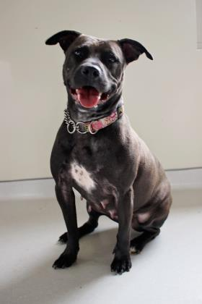
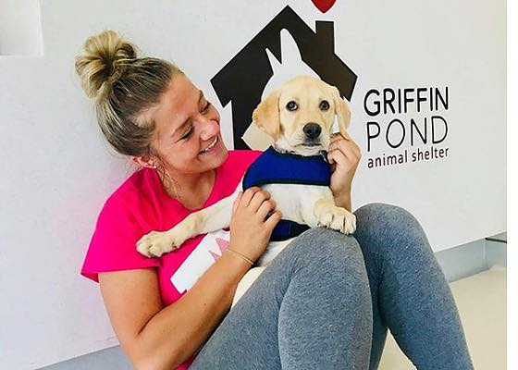

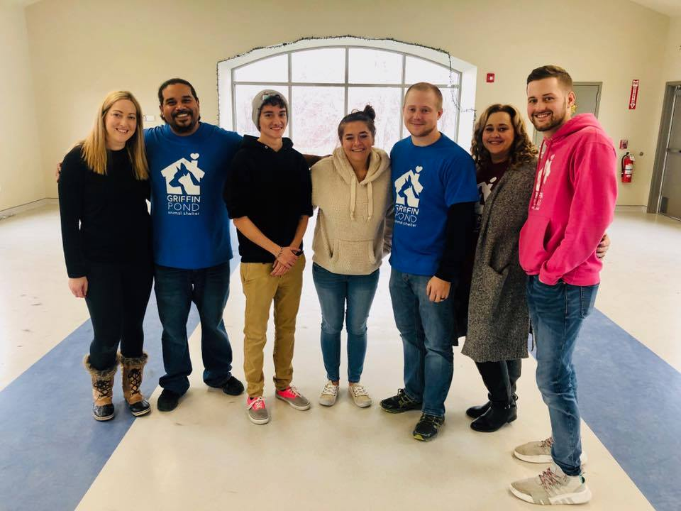
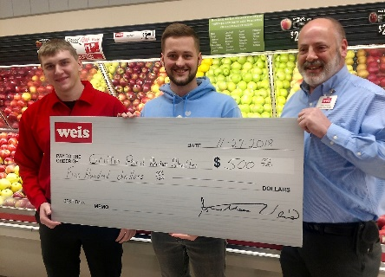
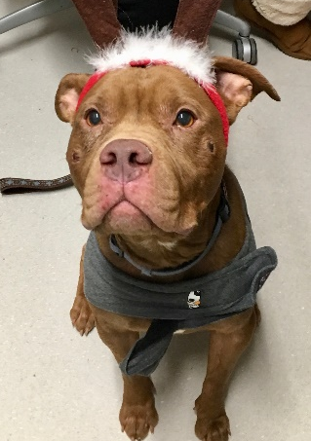
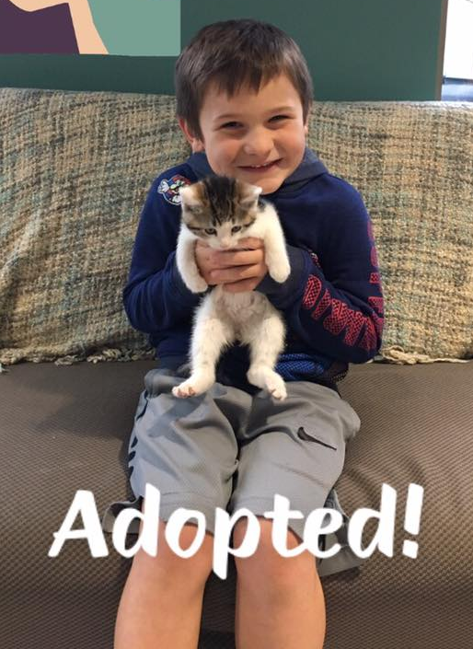
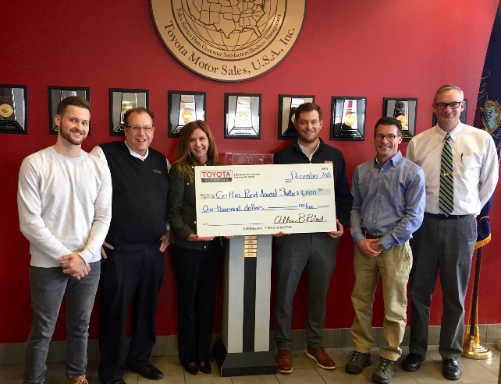
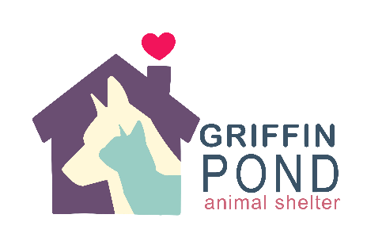
Griffin Pond Animal Shelter Humane Society of Lackawanna County

2019
Sponsorship
Opportunity

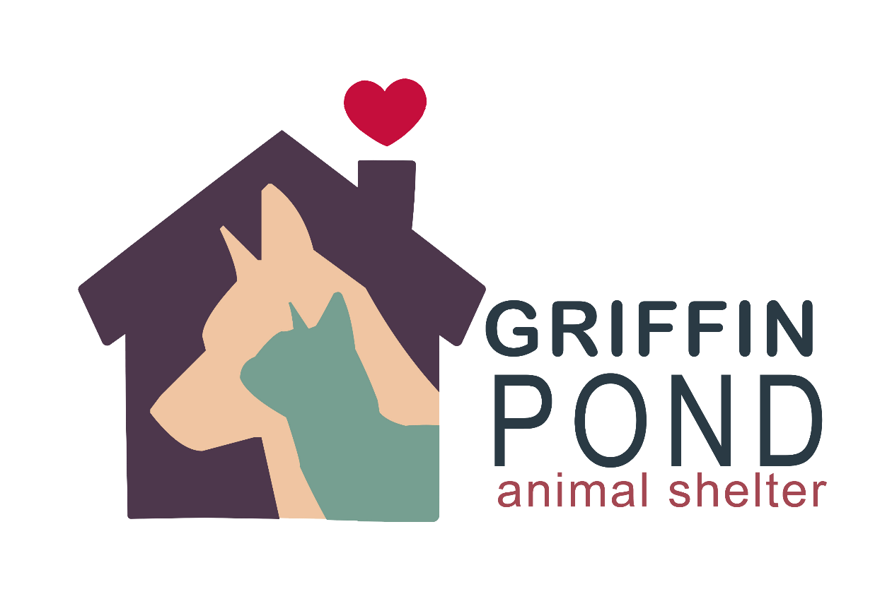

Our Mission
Our Mission is to investigate, help prosecute and prevent cruelty to animals while also promote adoption awareness and humane education plus responsible pet ownership. We promote this all while we care for the animals surrendered to our shelter to the best of our ability every day until we find them new loving homes.
​
Griffin Pond Animal Shelter was established as the Humane Society of Lackawanna County in 1938 to provide shelter for homeless, unwanted and abused animals. The shelter cares for over 200 animals on a daily basis, which is a considerable cost when you consider how much staff, food, medicine and supplies the shelter requires to operate. We also provide for animals that are sick, elderly and injured that are in our custody due to various reasons such as owner surrender and cruelty case investigations.
​
Our shelter is not affiliated with any other organizations and we are completely funded by private donations. Because we do not receive any federal, state or county funding, we rely on fundraising events and the generosity of caring people. With your support, these animals are given a second chance.

New Year, New Opportunities!
Become A Sponsor for Griffin Pond Animal Shelter Humane Society of Lackawanna County!
Give back to the community.
Promote your business.
P

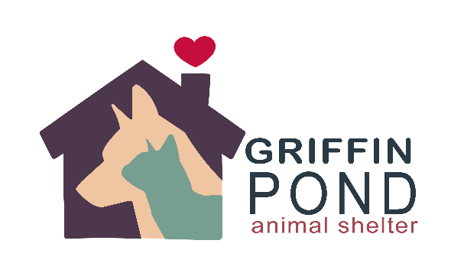

When you team up with Griffin Pond Animal Shelter as a sponsor, you help us open doors to a variety of different possibilities! With the assistance of sponsors, we can continue helping our community by caring for and controlling the population of homeless animals through spay/neutering and by providing education to families on how to properly care for their animals! By doing this, your business can create a positive outcome by improving the lives of so many animals throughout our community.
We can offer a sponsor a variety of exposure as a thank you for helping the animals in need! Whether its promoting your business on our social media pages with over 30,000 followers, being a part of our mass mailing which reaches to over 11,000 people, having your logo on our merchandise, or even having you be a part of some of our major events throughout the year. Partnering with us can give you a different kind of reach than you ever imagined!
Together, we can create a better future for Griffin Pond Animal Shelter! Won’t you consider becoming a sponsor?
“Leader of the Pack” Sponsor
$5,000
- Your brochures and/or business cards displayed at our “Sponsors” section in our main lobby.
- A custom plaque hung in our lobby with the wording of your choosing and business logo.
- A free booth at our “Paws in the Park” event. One of our biggest events of the year.
- Your business logo on the back of our t-shirts/sweatshirts for the “Paws in the Park” event.
- An official Sponsorship Certificate to be hung at your place of business.
- A personal “Thank You” to your business on our next major newsletter (print and email).
- Your logo and business information on our website under “Our Sponsors” section.
- Receive sponsorship offerings to major events.

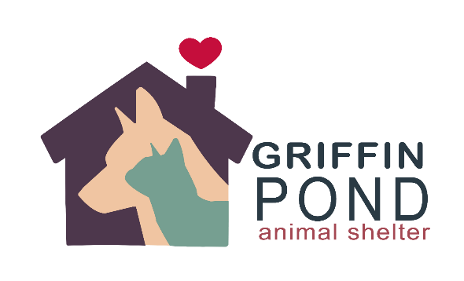
“The Cat’s Meow”
Sponsor
$2,500
- Your brochures and/or business cards displayed at our “Sponsors” section in our main lobby.
- A plaque that will be hung in our main lobby area.
- An official Sponsorship Certificate to be hung at your place of business.
- A personal “Thank You” to your business on our FB page.
- Your logo and business information on our website under “Our Sponsors” section.
- Receive sponsorship offerings to major events.

“Top Dog”
Sponsor
$1,000
- Your brochures and/or business cards displayed at our “Sponsors” section in our main lobby.
- An official Sponsorship Certificate to be hung at your place of business.
- A personal “Thank You” to your business on our FB page.
- Receive sponsorship offering to major events.

“The Purrrfect”
Sponsor
$500
- An official Sponsorship Certificate to be hung at your place of business.
- A personal “Thank You” to your business on our FB page.
- Receive sponsorship offering to major events.

Sponsorship Form (Please return with choice of sponsorship)

Contact Information:
Company Name: _____________________________________________________
Contact Name: _______________________________________ Phone: ________________________________________
Email: ____________________________________________________________________________________________
Street Address: _____________________________________________________________________________________
City: _______________________________ State: ____________________ Zip: ________________________________

Billing Information: (If different from above)
Contact Name: _____________________________________________________ Phone: _________________________
Email: ___________________________________________________________________________________________
Street Address: _____________________________________________________________________________________
City: ___________________________________State: _________________________ Zip: _______________________

Level of Sponsorship:
□ The Purrrfect Sponsor ($500) □ The Cat’s Meow Sponsor ($2,500) □ I am choosing to provide a different
□ Top Dog Sponsor ($1,000) □ Leader of the Pack Sponsor ($5,000) amount as donation to the shelter.

Payment Information:
____ Check enclosed (Payable to Griffin Pond Animal Shelter) ____Visa ___ Mastercard
Cardholder Name: __________________________________________________________________________________
Card Number: ___________________________________________ Exp: ____/_____ CVC Code: __________________
Signature: _________________________________________________________________________________________

Please mail complete page with payment to: Your donation is tax deducatible.
Griffin Pond Animal Shelter Our Federal Tax ID is 24-0831491
Attn: Sponsorship
967 Griffin Pond Road
S. Abington Twp, PA 18411

